Chapter 1 Computers Hardware and Software

Session Objectives :

At the end of this session, the student will be able to -

Hardware concepts
- Discuss “The City Inside” and the components inside the CPU like the -
- Mother board (Main board)
- Bus
- Cards
- Ports
- Memory
- Hard Disk Drive
- Floppy Disk Drive
- Power Supply Unit
- Computer Clock
- Classify Computers
- Identify a typical PC Configuration of -
- An ideal PC
- Multimedia – The magic of technology

Software concepts
- Define Software
- Explain Software with examples
- Classify Computer Languages
- List varieties Of Software
- Summarise the Role Of Software
- Describe what is Housekeeping
- Discuss the Booting Process
- Discuss various concepts related to software like:
- Virus, Anti-virus and Vaccine
- Data Compression Techniques
- File Creation
- Versions Of Software
- Software Manuals
- Software Copyrights
- Software Upgrades

Computer Hardware

1. 1 “The City Inside”

If you stood on a tall building and looked around you, the city would look like a miniature replica of itself. The first thing that strikes you when the CPU is opened and when you look at its internal parts is that, the whole scene resembles this miniature city. The computer is a result of all these parts working with each other in smooth coordination. This session is devoted to understanding these parts for getting a better grasp of computers as a subject.

1.1.1 Bus, Ports, Cards and Motherboard

We look at input and output devices as the means to communicate with the computer. That is true from our point of view. However, the computer has much more input/output work than that. Millions of bits of data and instructions are speeding along, through the components of your computer. This is happening even while your computer seems to be idle. As a busy highway with a lot of traffic has many policemen to make sure that there are no accidents, the input/output work in a computer is also controlled by controllers who work with the processor to make sure that there is no clash of data.

On what does all this data speed along? Like the cars on the highway have the road to speed on, the data in a computer speeds along a bus. It is the bus that transports data between the processor and the other components. There are several types of buses that facilitate transfer of data. One is the data bus and the bus which controls all the data flow is the control bus. A bus is not a single part of the computer, but is actually a complex group of circuits. These circuits are present all over the motherboard; on the top and the bottom.

The microchips that are seen inside the computer are also called buses. These microchips allow the computer to include more parts. For this purpose, these buses have slots in them in which cards can be fixed. Hence this bus which allows the expansion of the computer is called the expansion bus.

While the transfer of data takes places through the bus, the entry and exit points of these buses are called ports. Ports are access points for the entry or the exit of data. Some ports allow only a single bit of data to pass through. Such ports are called serial ports. The term ‘Serial’ is used because the entry or exit of data bits happens in a line one after the other, similar to a line of marching soldiers. Naturally, the time taken for data to get transferred from one place to another will be more because only one bit is allowed to enter or exit at any point of time.

Serial ports are used mostly with the mouse. It is, sometimes also called the RS-232 port. RS-232 refers to the Electronic Industry Standard on how the connectors in a serial port should be used.

Some ports however, allow the passage of more than one bit, i.e. 8 bits at a time. Such ports are called parallel ports. Transfer of data through parallel ports is much faster because 8 bits can travel together (parallel to each other) from one part of the computer to another. The time in which the serial port can transfer the letter ‘c’ from one part of the computer to another, the parallel port can transfer the entire word ‘computer’ from one part of the computer to another.

Parallel ports are used with printers. Parallel ports are therefore also referred to as printer ports and sometimes called the Centronics port. Parallel ports are also being used for transferring data files between two computers.

USB ports

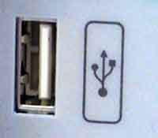
A Universal Serial Bus port, introduced around 1997, is the gateway to your computer. It's used to connect all kinds of external devices, such as external hard drives, printers, mice, scanners and more. There are normally two half-inch long USB ports on the back of computers built since 1998. Sometimes there are USB ports built into a hatch on the front of a computer. If you use a USB hub, (example: 4 port hub), you can connect as many as 127 devices to a USB port. It can transfer data to a speed of 12 megabits per second, but those 127 devices have to share that speed. Since USB-compliant devices can draw power from a USB port only a few power drawing devices can connect at the same time without the computer system complaining.
In 2003, USB 2.0 connectors were introduced on computers. These transfer data at 480 Mbps. Older USB devices work with USB 2.0 ports, but at 12 Mbps. USB 2.0 devices also work with older USB ports, again at the lower speed. USB 2.0 is useful for adding external hard drives, flash drives.

1.1.2 Memory

Memory is classified into two types:

- Primary Memory
- Secondary Memory

- Primary Memory

It is also called the main memory or the central memory. It is of two types – RAM and ROM.
RAM is essentially a read/write memory. Information can be written into and read from a RAM. It is volatile in nature, i.e., it retains the stored information as long as power supply is not switched off. It is usually sold and installed to a standard adding board called a Single In-line Memory Module or SIMM. RAM can be bought separately in case you want to expand the primary memory of your computer.

RAM chips may be classified as :

- Dynamic
- Static

Dynamic RAM chips - The storage cell circuits contain :

- a transistor (functions like a mechanical on-off light switch)
- a capacitor used to store an electric charge

Data is stored in computers in the binary form, i.e., it is stored in 0’s and 1’s.

Depending on the switching action of the transistor, the capacitor may have no charge (0 bit) or hold a charge (1 bit). The charge on the capacitor must be periodically refreshed or recharged. In the event of power loss dynamic RAM loses its contents. It is thus called volatile storage.
Static RAM chips - are also volatile storage devices. However, as long as they are supplied with power, they do not require special regenerator circuits to retain the stored data. More transistors and other devices are needed to store a bit in static RAM. These chips are more complicated than dynamic RAMs. Static RAMs are used in specialised applications. Dynamic RAMs are typically used on the primary storage section.

ROM is a permanent type memory. It’s contents are not lost when power supply is switched off. Data is hardwired onto these chips at the time of manufacture. They cannot be changed by the user.

While both RAM and ROM are storage devices and can be accessed randomly, they differ in that data can be written onto RAM while ROM does not permit the user to write onto it.

ROM retains the data in it even in the absence of power and is thus non-volatile storage. Though data is hardwired, the user is able to program the following types of ROM :

- PROM Programmable Read Only Memory (PROM) allow microprograms to be fused into them. These microprograms consist of critical or lengthy operations that are slowly carried out by software. Once they are in hardware form these tasks take a fraction of the time. Each bit can be individually programmed to a "1" or "0" by burning out a fusible link within the selected cells. A fused link cannot be restored. Operations once written cannot be erased. PROM can be programmed only once.

- EPROM The Erasable Programmable Read Only Memory makes it possible for the user to repeatedly erase and reprogram the ROM. Erasing is done by exposing the EPROM to Ultra Violet rays of a specific frequency.

- EEPROM An Electrically Erasable Programmable Read Only Memory can be programmed through the use of special electrical pulses. It is possible to integrate the circuitry into the computer, so that the EPROM does not have to be removed from its socket for programming.

Devices such as PROMs, EPROMs, EEPROMs are all used in computers, with the later versions being used in newer models. A ROM is used when its contents are thoroughly debugged through the use of EPROMs and do not require changes. EEPROMs on the other hand, are especially useful in process control equipment, in which a real-time response is necessary, but when the software is being continuously modified.

- Secondary Memory

The secondary memory is found outside the CPU box and hence sometimes called the external memory or the external storage. Examples of secondary storage devices include floppy disks, tapes, cartridges, compact discs, etc

1.1.3 The Hard Disk Drive

The hard disk drive is the work horse of the computer system. The hard disk can be thought of as a collection of many floppies or gramophone record stacked on each other without all of them actually touching each other. These are called platters. The gap between these platters is as thin as a human hair. These platters have data stored on them, that may actually be the result of years and years of work. Data is stored or retrieved from the disk using a conducting coil called the head. During a read/write, the head is stationary while the platter rotates at a very high speed beneath it.

The head can read/write from a portion of the platter rotating beneath it. Data is organised in a set of concentric rings called tracks. Each track is the same width as the head. The same number of bits are typically stored on each track. Thus the density increases towards the innermost tracks.

Data is stored and retrieved from the disk in blocks. Data is stored in block-size regions called sectors. The sectors may be of fixed or variable length. Adjacent sectors are separated by intra-track gaps. Certain control data is recorded on the disk to identify the start and end points of a sector. This data is recorded during formatting and is used only by the disk drive. It is not accessible to the user.

A number of characteristics are used to differentiate between disks :

Tracks

Figure 1 – Fixed Head

Tracks

Figure 2 – Movable Head

The head may be fixed or movable. In a fixed-head disk there is one read/write head per track. The heads are mounted on a rigid arm. The arm extends across all the tracks. In a moveable head disk there is only one read/write head. The head is mounted on an arm which can be extended or retracted.

The disk is mounted on a disk drive. This consists of the arm, a shaft that rotates the disk and the electronics required for the input and output of binary data.

In some disk drives, multiple platters may be stacked vertically. Multiple arms are used and the entire unit is called a disk pack. The read / write head is positioned at a fixed distance from the platter allowing an air gap.

A set of corresponding tracks on all surfaces of the disk pack equidistant from the spindle is called a cylinder.

Commands to read or write are received from the computer by the disk controller. For writing on the disk pack the computer specifies the drive number, cylinder number, surface number and sector number. The disk controller positions the arm assembly so that the read/write head reaches the specified cylinder. The time taken to reach the specified cylinder is called the seek time. Seek time varies depending on the position of the arms assembly when the read/write command is performed. Maximum seek time is taken when the arms assembly has to move from the outer most track to the inner most track. Minimum seek time is taken when the arms assembly is already positioned over the required cylinder.

Switching is the process of switching the read/write head from one sector to another and it is an electronic and instantaneous operation. After the head is selected there is further delay - rotational latency, because the required sector must reach the read/ write head.

Thus,
average access time = average latency + average seek time

Once the sector is reached, data is read at the speed determined by the rotational speed of the disk.

The full set of these platters and the read and write heads are enclosed in a vacuumed container, to protect it from dust and electrical shocks.
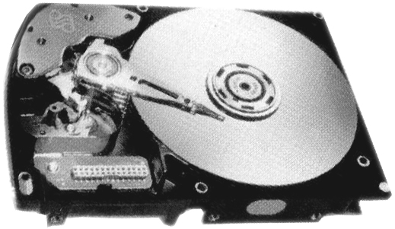

Figure 3 – Hard Disk

When the hard disk is being accessed, it makes a peculiar groaning sound. This indicates that the hard disk drive is an example of a device that is both mechanical and electronic.

1.1.4 The Floppy Disk Drive

The computer would be very incomplete without the floppy drive. A floppy disk allows information to be exchanged between two computers. All that needs to be done is to insert a floppy in the drive, copy the data from the hard disk to the floppy, and insert it in the machine where that data is required. It is still one of the easier and cost effective ways to exchange information or data between two computers.

The floppy is actually enclosed in a plastic jacket that protects it from heat, dust and electrical shocks. When a floppy is exposed to any of the above, two things can happen:

- the floppy can be physically damaged, which can lead to loss of the data which is on the floppy
- the floppy may remain intact, but there may still be a data loss.

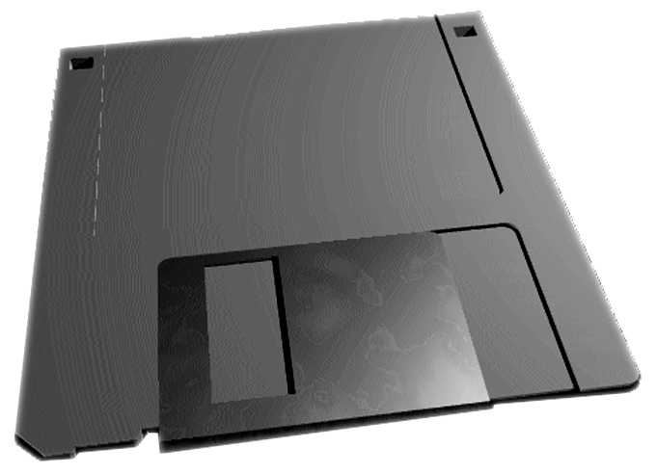

Figure 4 – Floppy Disk

Write Protect: Floppies are most commonly used for taking backups. It would not be a very pleasant experience for a person to carefully take a backup, only to have it accidentally erased by another colleague, or worse still by himself. One way is to label the floppy correctly as a backup floppy. This would certainly avoid such an accident. Another more effective way would be to write protect the floppy, i.e. protect it from being written on.

In a 5.25 inch floppy, this is done by sticking a small tape on the notch that is found on one side of the floppy. In a 3.5 inch disc, there is small square hole on the opposite side from where the floppy is inserted. When this hole is not fully see through, then the floppy is said to be a ‘writeable’ floppy. When the hole can be seen through, then the floppy is said to be write-protected. This is manipulated by a small push button. By pushing the small button in or out, the floppy can be made writeable or readable.

1.1.5 Power Supply Unit

The power supply unit checks the quality of the power supply and ensures that the right amount of power gets supplied to the various parts.

1.1.6 Computer Clock (real time clock)

All computers have a real clock built inside which is attached to the motherboard. This clock works on a separate battery source. Therefore it remains working even when the computer’s power supply is switched off. The reason for having this facility in a computer is to allow the operating system to keep a record of the time and date of file creation. This allows the user to maintain versions of old and new files.

1.2 Classification Of Computers

Although a clear cut classification of computers is difficult, computers can be broadly classified on the basis of purpose, components and size and processing power.
1.2.1 Purpose

- Analog Computers
- Digital Computers
- Hybrid Computers

a. Analog Computers

Analog computers are computers that measure physical quantities (e.g. pressure, temperature, length etc.) and convert them to numeric values. For example a thermometer does not perform any calculations but measures the temperature of the body by comparing the relative expansion of mercury.

- Uses : Analog Computers are used mainly for scientific and engineering purposes because they deal with quantities that vary constantly. They give only approximate results.

b. Digital Computers

Most computers are digital devices i.e., they process information using numbers which is essentially in a binary or a two state format.

- Uses : Special purpose digital computers can be fixed permanently into the machine. For e.g. processors that are installed in automobiles to control fuel, braking systems etc.

General purpose digital computers can be used in different applications since they can store different sets of instructions and programs.

c. Hybrid Computers

The features of analog and digital machines are combined to create a hybrid computing system. For e.g. analog devices measure a patient's vital signs like temperature, heart functions, etc. These are then converted to numbers and supplied to the digital components that monitor the patient's vital signs. Any fluctuation can thus be noticed immediately.

1.2.2 Components

The earliest computers were mechanical computing devices. However, over generations the computer has developed from a huge mechanically operated device to convenient, portable desk tops and lap tops that function on the basis of small chips and integrated circuitry.

The first generation computers used vacuum tubes to store data and programming instructions. Data was represented in 1's and 0's or states of "on" and "off".

However, vacuum tubes consumed a large amount of electricity, produced large amounts of heat, and were relatively unreliable. They were soon replaced by solid-state transistors.

The second generation of computers was thus characterised by the use of transistors in place of vacuum tubes.

In the third generation of computers integrated circuits on chips (thin wafers of silicon) were used to store data and process instructions. These computers could handle more than one operation simultaneously.

The more the circuits on a single chip, the greater is the amount of data that can be stored on that chip. While the technique of integrating circuits on a single chip was established during the third generation of computers, it was in the fourth generation of computers that Large Scale Integration (LSI) and Very Large Scale Integration (VLSI) of transistors on a single chip were used.

It was now possible to put the entire processor of the computer on a single chip. Intel Corporation developed the first Intel 4004 microprocessor chip. A microcomputer is built using a microprocessor chip, along with some other chips and circuitry.

A whole range of "personal computers" that could be used for generalised applications became popular. The PC, PC-XT and the PC-AT are some of the personal computers to be popularised by IBM (International Business Machines). While the PC and the PC-XT differ only in the disk storage supported by them, the PC-AT differs in the processor itself.

The Intel 8088 microprocessor chip is used in PC's and PC-XT's. PC-AT's use the Intel 80286 or Intel 80386 chips as their microprocessor.

There are other chips like the Motorola 68020, Motorola 68030, Zilog 8000 etc. used to build other microprocessors.

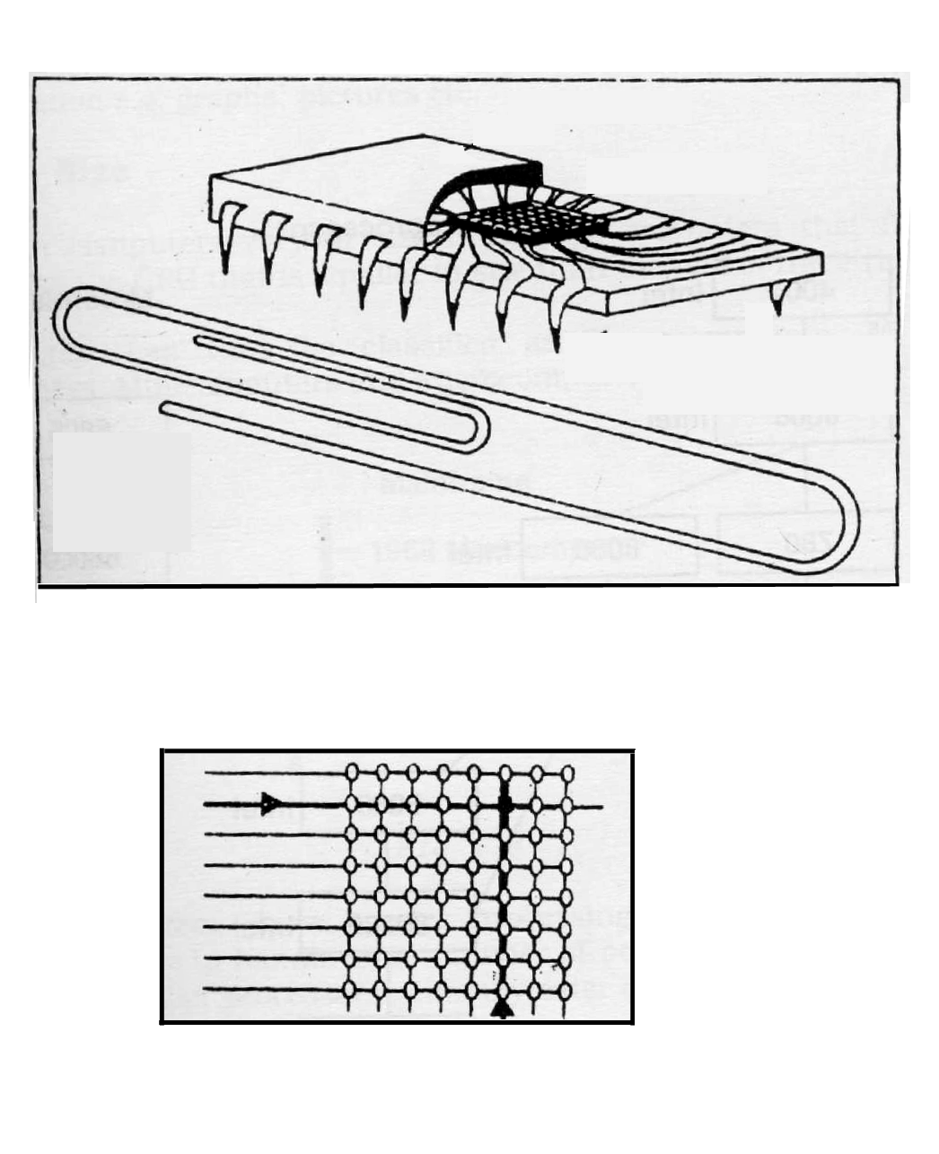
Protective casing
Silicon
chip
Set of edge connectors
(both sides)

Standard size paper clip to roughly the same scale.
Cells in this row are open
Column lines
Referenced cell
Row lines
Figure 5 - A computer component containing a silicon chip.

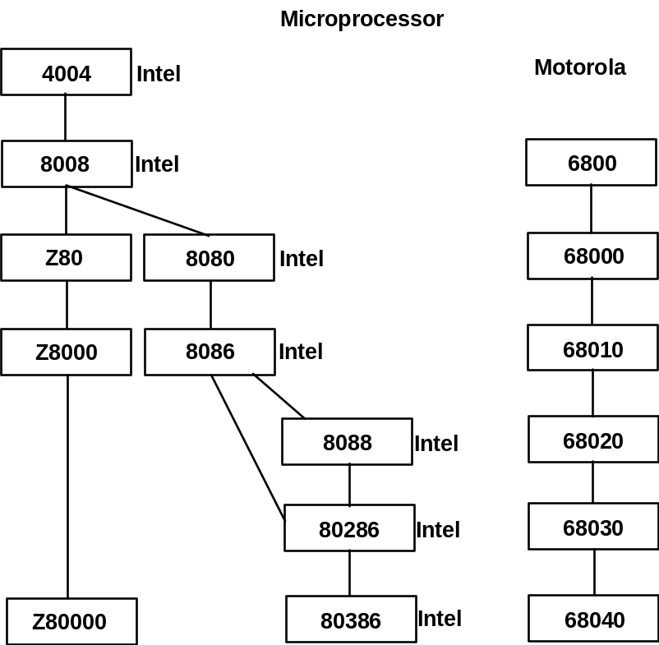
Intel
Intel
Intel
Intel
Intel
Intel
80486
80586
Pentium - I
80586
Pentium - III
Celeron - 233
Celeron - 300
Celeron – 300 A
Intel
80586
Pentium -II
Intel
80586
Pentium - IV
Intel
Itanium
(64-bit)

Figure 6 – Microprocessors

The fifth Generation of computers are conceived as a knowledgeable information processing system. It incorporates Artificial Intelligence. Modeled on human intelligence, they are self learning systems which can store experiences and take decisions based on the information and logic stored in the computer. They can also process non-numeric information e.g. graphs, pictures etc.

1.2.3 Size and Processing Power

Modern computers vary in size and processing power from large computers that fill entire rooms to the CPU that is smaller as compared to the nail of the little finger.

Computers can thus be classified as Supercomputers, Mainframe computers, Minicomputers and Microcomputers, according to their size and processing power.

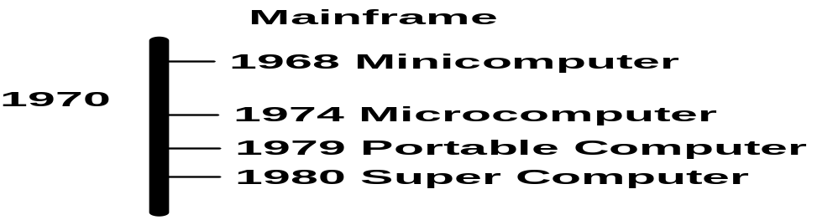

Figure 7 – Classification of computers on the basis of size and processing power

While large systems have greater processing speed, possess greater storage capacity and are able to handle a large number of powerful input and output devices, the smaller processors generally cater to single users. They may be

1. Special purpose devices performing a single task. For e.g. controlling the ignition system in an automobile.

2. Personal computers ranging from the desktop model to the laptop, or to the notebook.

Microcomputers

The microcomputer is the smallest type of computer available. Inside a microcomputer, the arithmetic and control unit are combined on a single chip called a microprocessor. Microcomputers contain two types of storage or memory.

- Random Access Memory (RAM) .

- Read Only Memory (ROM) .

Microcomputers are used as home computers for the family, or as personal computers by business executives or by small businesses where volumes of data processing and speed requirements are small.

These computers are popular as home computers, having a small memory which uses the household TV as the display device and a cassette player or a small capacity floppy for backing storage.

Personal computers have slightly better capabilities. They are single user systems, having a separate monitor for display and floppies or Winchester drives for backing storage. They are generally used for business applications. Currently, the IBM PC (Personal Computer) in various configurations and IBM-PC "Compatibles" are the most popular small-business computers.

A microcomputer may also be used by individual professionals like:

- a doctor to maintain records of his patients.
- a chartered accountant to keep the financial records of his clients.
- a small to medium size retail store for maintaining financial as well as stock accounts.
- managers in large corporations for their MIS and decision support needs.
- organisations as a part of a network linked to other computers.

Microcomputer workstations are also extensively used for Computer Graphics, Computer Aided Design (CAD) and Computer Assisted Manufacturing (CAM) applications. Graphics workstations can manipulate lines, curves, figures and engineering or architectural drawings efficiently.

Minicomputers

Minicomputers are more powerful than the microcomputers and can support several users. They have larger RAM and backing storage capacity and can process data more quickly.

The first popular minicomputer was the PDP-8, launched in 1965. Minicomputers were basically developed for use in process control systems. The minicomputer has been diversified to handle common applications also. A medium sized organisation may use it for applications like processing of payrolls and financial accounts, handling costing, sales analysis, production planning and a host of other similar activities. Minicomputers may also be used for systems like reservation or banking.

Examples of popular minis are the PDP-11, the VAX 7500 and the AS 400.

Mainframes

The earliest computers were called mainframes due to their large size. The term is still used for the large computers today. The capacities of the earlier mainframes and the mainframes today are enormously different. Today's mainframes are far more powerful, so much so, that a microcomputer today comes close to the processing power of an earlier mainframe.

Mainframes are very large computers with a very high capacity of main store. Because they can process large amounts of data very quickly, they are used by big companies, banks and government departments as their main computer. They can be linked into a network with smaller departmental computers, microcomputers or with each other. They act as hosts of large national and international communication networks, handling hundreds of users.

A further development in mainframe computing has been that of distributed systems. In a distributed system, some processing power is provided at the local end of a company's communication network, and the other end is linked to a (usually larger) central computing facility.

Some examples of mainframes are the IBM 4381, ICL 39 series and CDC Cyber series.

Supercomputers

Complex scientific applications like weather forecasting require a large amount of data to be manipulated within a very short period of time. Supercomputers, which allow faster processing by using multiple processors and superior technology are used for complex tasks which require a lot of computational power.

The traditional design of a single processor handling data and instructions in a single stream is called the "Von Neumann design". Supercomputers typically, use "non-von Neumann designs". They have multiple ALUs (Arithmetic and Logical Unit). Each ALU is specialised for a particular operation, and all capable of performing simultaneous or "parallel" processing of different tasks. Control is maintained at several points, with an overall controller in charge.

Examples of supercomputers are CRAY XMP-24 and NEC-500.

1. 3 Typical PC Configuration

Configuration refers to the manner in which the hardware and software of an information processing system are organised and interconnected. When a computer is bought, it has to be configured. Configuring a computer is a process that describes the devices and optional features and programs that the system will have.

This simply means that the user will have to decide what are the parts that he will require to make most out of his computer. Not only the parts, the ‘power’ or the capacity of those parts is also important. Hence, the following needs to be decided.

The recommended PC configuration

The specifications for these will keep changing because technology is advancing at a very rapid pace. So what is advanced today, will become the minimum requirement of tomorrow. Let us now take a look at the configurations given below.

One needs a car to travel from one place to another. This is the basic use of a car. However, today the market is full of different types of luxury cars that allow the traveller to do much more than going from one place to another. Stereo systems, air conditioning, power steering, soft cushioned seating, glass holders and many other luxuries that make travelling by a car seem like a dream! These are the accessories that make driving more pleasurable. This does not mean that a car that does not have all these will not take you from one place to another. It will, but the going will be quite rough.

Similarly, there are computers that can process data, allow typing of letters and do accounts. But they may not offer the comforts of the latest technologies like GUI and colour.

Now let us see what a recommended PC configuration would be. A PC that would be able to make full use of the current software available in the market (12/2004):

- P4 3.0GHZ
- Bus 800
- Cache 1MB
- Motherboard Intel 915GAV/2x
- Ram 256MB
- HDD 80GB (7200 rpm)
- DVD 16X
- FDD1.44MB
- A keyboard
- Mouse Optical
- Monitor 17"
- Modem (Fax and Connect to the Internet)
- USB port
- Parallel port for the printer
- Serial ports
- Sound Blaster (Sound Card)
- Speakers
- Windows 2000/ XP /2003

This configuration is meant for a stand-alone computer. If the computer is to be a part of a network, then an additional card called the network card(NIC) is required.

1.3.1 The Magic of Multimedia

The current generation has a whole lot of us glued to our TV sets. We are so involved with the TV today, that we forget ourselves, our families and naturally, our duties too. While, we do not want to discuss whether all this is right or wrong, good or bad, we certainly want to understand why this has happened?

The amazing thing about a TV is that it is a combination of sound (audio) and pictures (video) which appeal to us a lot. Add to this scene some interactivity in the form of the host ‘talking’ to you directly, asking you to write or call in, and this really thrills us. Repeating the point above, the three key factors that are responsible for the TV becoming so popular are:

- Audio
- Video
- Interactivity

Now imagine the computer being able to offer the above mentioned aspects. The effect would be just as mesmerizing. Each of these is considered to be a medium of communication. When 3 such media combine in a computer, then the computer is called a multimedia computer. Having a multimedia computer would be the most ideal PC to work on.
Computer Software

1.4 Software

Software is as important to the computer as television serials are to televisions. Would you use a TV if no one made any serials, if there was nothing called ‘News’ every night? Certainly not! Similarly, you would not need computers if there were no software to make the computer work. That is exactly how important software is to computers. It is the software that eventually converts data into information. Software allows us to use the computer in many different ways. We will devote this session to understand everything about software and how it completes the computer system.

The Definition:

Software can be defined as a set of instructions that are given to the computer, which help the computer to process data and give information. These sets of instructions are called ‘programs’. Program is a term that we use in our daily lives very often. Program, as we use it in our daily lives refers to a schedule of how a certain job will be done. We normally refer to the word program when we want to plan our day. Computers also use the same term because of the similarity in the way instructions are given. A typical daily program of a student would look like this:

NIGHT.
Sleep till your eyes open in the morning.

WAKE UP.
If it’s not 6:00 am yet,
go back to the NIGHT routine.
If it is Saturday or Sunday
go ahead to the WEEK-END routine.
Wake up.
Eat your breakfast.
Go to college.
Go for the Aptech class
Come home.
Have dinner while watching TV.
Go back to NIGHT.

WEEK-END.
Sleep late.
Eat breakfast.
Eat more breakfast.
Sleep for sometime again.
Watch TV
Meet friends.
Have lunch.
Meet more friends, watch more TV.
Have dinner
Go back to NIGHT.

This is how a daily program is made. A computer program is made on similar lines. Software can be considered as a collection of several such programs, which work towards processing data.

1.5 A Sample Application

To understand the meaning of software, we will consider the following example. The college that you go to conducts exams every year. The marks that are obtained by the student are listed on paper against the names of the students according to the class and divisions. Normally, someone would have to sit down and use a calculator to calculate the percentage of each student, in each and every class. Doing this type of work is often referred to as doing a job ‘manually’. When a machine is used to do something, the job is no longer called manual, it is called automatic.

Next, on another set of papers, some calculation would have to be done to get information like -

- which student scored the highest marks
- what is the average marks scored in each subject
- which is the class that scored the highest marks

After these calculations are done, the meaning of these marks becomes more clear to us. Just lists of these marks do not really mean much unless some work or processing is done on them. It is the software that will convert this list of marks into some meaningful information. Suppose you want the following information along with the marks:

- The percentage obtained by each student
- The average marks obtained in each class, in each subject
- The highest marks obtained in each subject
- The highest total of all the subjects

To get all the above information, programs will be required. As mentioned earlier, programs are nothing but sets of instructions given to the computer. How does the computer understand instructions given to it? In computers everything is numeric or in the form of numbers. So how does the computer receive instructions from us?

The computer receives instructions from us in the form of programs. Several programs need to be made or written for each of the task described above. Sometimes one program is sufficient for one task. Sometimes you need several programs for one task. In order to accomplish each of the tasks, the concerned program has to be used. To enable the computer to process the above information we need to look at the following diagram:

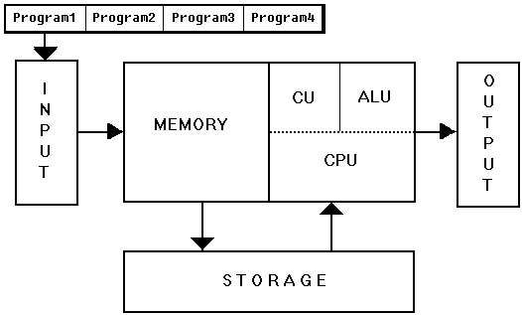

Figure 8

In the diagram given above, the following programs have been written:

Program-1: This program allows the user to enter data, in this case the marks into the computer.

In our example above, running the program ‘Program-1’ will allow the user of the computer to see a screen on the monitor as shown below. This screen will prompt the user to enter the following detail:

Class:__________________ Division:___________ Professor:______________

Roll No. ____________ Name Of Student :____________________________

Chemistry : ________
Math : ________
Physics : ________
English : ________
F.C : ________

Figure 9

This screen will enable the user to enter all the marks obtained by each student.

In the screen shown above, the user knows exactly where to enter the student’s name, student’s roll number etc. This is because the screen has the exact headings, which clearly indicates what part of the data has to be entered where.

This is what is called being friendly to the user. When the user of the software does not have any difficulty in using the software, it is called user friendly software.

Program-2: This program calculates the percentage of each student against the total marks that have been obtained by them.

So therefore, the user will have to run Program-2 to find out the percentage of each student. Here the user will get a report that would look like this:

Class: Science – Year 1 Division: A Professor: Prof. Andrews

Total Marks: 500.

Roll No | Name | Marks | Percentage
1 | Paddy | 368 | 91.2
2 | Ron | 456 | 73.6
3 | Anita | 290 | 58

Table 1

Program-3: This program calculates the average marks scored in each subject for every class. This will also give an output similar to the one shown above. The report can look like this:

Class | Average-Math | Average-Chemistry | Average-Physics
Science – Year 1 | 45 | 60 | 39
Science – Year 2 | 23 | 50 | 40
Science – Year 3 | 44 | 61 | 38

Table 2

Similarly, the average marks for other subjects can also be obtained.

Program-4: This program arranges the marks in the order, of highest to lowest to be able to determine the ranks of all the students.

Class: Science – Year 1 Division: A Professor: Prof. Andrews

Total Marks: 500.

Roll No | Rank | Name | Marks | Percentage
2 | 1 | Ron | 456 | 91.2
1 | 2 | Paddy | 368 | 73.6
3 | 3 | Anita | 290 | 58

Table 3

This type of a report generated by the computer is called the output. This can be seen on the screen as well as be obtained on the printer.

The two advantages of having these programs here are:

- This writing of programs is a one-time effort. Once these programs are made they can be used every year after each exam.

- The example taken here is quite simple, but there are many complex operations that really need to be done using the computer.

1.6 Explanation of the Sample Application

All along in the sessions that we have discussed so far, words like data, information, processing, storage and files have been used. Now we will understand these terms with respect to the example given above:

Program: Program refers to the set of instructions that have to be written for the computer so that it is able to process data to give the desired information. Programs are written by people who have the required knowledge of how to communicate with the computer. The tool that is used for writing the set of instructions is called a computer language. Computer professionals who know how to use the tools available to write programs are called programmers. These instructions are ‘stored’ on the hard disk in the computer, for use whenever required.

To execute a program, first it has to be loaded. Loading is the process of copying the program from the hard disk to the RAM. Once this is done, the program starts functioning and performing the task it is supposed to do. This functioning of the program is called executing or running the program.

Application: A related set of tasks is called an application. When many such programs are written for a related set of tasks or application, then it is called application software. When an application is carried out using the computer then that application is said to be computerised.

Data: In the example given above, data are the marks obtained by the students of the entire college. This data needs to be ‘kept’ somewhere, so that it can be used for processing. In computers everything is ‘kept’ in files. Files are storage places created on the external storage devices like the hard disk. Files that contain data, like the marks of all the students of the college are called data files.

When the user enters the marks of the first student in the computer, a data file gets created. This creation of data file is done by the operating system. It is not possible for the user to enter all the data at once. So the file needs to be ‘saved’ for future use. When a file is saved, it gets written on the hard disk. It remains there, till the time the user wants to add more data in it. If the contents of the file are not required the file can be closed. Thus, closing the file is the process of telling the operating system that the contents of this file are not required for the time being. When the user wants to use the same file again, he/she will have to open the file. Opening the file is a process where the operating system of the computer will search for the file and get it ready for use. As the user goes on entering the data the file keeps on getting larger and larger as the number of students in the file increase. This file is now said to be modified.

Summarising, a file, in the course of its use gets

- created
- closed
- saved
- opened and
- modified

Process: Once the data has been entered through the input device and stored in a data file, it can be worked upon any time to obtain information. The process that will be done on the data files created in the above example, will come in the form of Program-2. Program-2 contains the necessary instructions to take the marks of each student and calculate the percentage. This program, like the program that allows the marks of the students to be input in the computer also needs to be stored in the computer. These programs are also stored in the form of files and they are called program files.

Information: All the programs explained in the above example have some type of output. Program-2 generates a list of all the percentages scored by each student. This output is called information. For any information to be available, a program has to be executed first. This information does not get stored anywhere. This is because, if the data and the program that generates the information, are both present, there is really no need to waste storage space in storing more data. In a case where the information is required to be made available for future use, the information can be printed on paper using the printer. These printed sheets can be stored for a long time.

When a simple application like a wordprocessor is used for writing letters, the file that gets created is called a text file because the file contains simple readable text. Text files can also be called data files.

Summarising what has been covered above, it can be said that there are three types of files:

- Data files
- Program files
- Text Files

1.7 How Does the Software Get Made?

Software is a collection of big and small programs. Programs in turn are a set of instructions made in a sensible order. These instructions have to be written for each program that a software is made up of. So how does this get done? Consider this common example. All of us talk to each other using a language. People all over the world speak in different languages. In order to communicate with one another, we require to speak a common language. If there was no common language between two people, there would be no communication between them. Similarly even computers have to be ‘instructed’ by us if we require them to do our work. These instructions are given using a tool called a ‘computer language’. This tool helps the user to communicate with the computer to get work done.

The instructions to the computer are given using 0’s and 1’s. Can you imagine that? If you want to say

ADD 2 + 2

to the computer, separate codes will have to be written using 0 and 1 for A, D, another D, the symbol ‘+’ and 2 and another 2. This would indeed be very difficult. However, that is the way instructions were written earlier. Luckily for all of us, this is not the way computers are ‘instructed’ anymore. Things have become very easy now. To understand how this happens, a brief discussion on computer languages and its types is given next.

1.8 Computer Languages

As humans have languages to talk to each other, similarly there are languages to communicate even with the computer. A language involves the use and learning of words, sentences and grammar rules. The same is true for a computer language.

Computer languages have been classified according to the way they got evolved. Their evolution depended a lot on the way the computers were evolved. Each type of computer had a different type of language associated with it.

Classification of Computer Languages:

Computer languages have developed a great deal since they were first used. Their evolution spans about four stages, which are referred to as generations. Each generation has it’s individual characteristics.

- First Generation Language: The first type of language that was used for computers consisted of zeroes and ones as mentioned earlier. All instructions that had to be given consisted of zeroes and ones. Not only that, some of them involved manipulation of the machine itself by using switches and other controls. This language was able to ‘speak’ to the machine directly. Thus it was also called machine language. This was used on computers of the first generation, which used vacuum tubes.

- Second Generation Language: The computer users soon realised that to get more out of the machine, it was necessary to make communication with the computer easy. This led to the development of assembly languages. Assembly languages used mnemonics (pronounced as ‘ne-monics’). Mnemonics are nothing but shortcuts to long commands. A very common use of mnemonics in our daily lives is the way we remember the colours of the rainbow. Using the word VIBGYOR makes it easy for us to recall all the names very easily. In the same way, using mnemonics also made the job of writing programs slightly easier, but the bulk of the job remained very lengthy and tiresome. Assembly languages were used in the second generation machines like IBM 1401. These machines used transistors instead of vacuum tubes and hence were far more reliable than the first generation machines. First and second generation languages are also called low-level languages.

- Third Generation Language: For the first time computer language was made to look and sound similar to the English language. Almost all the codes of 0 and 1 were converted to English commands. These languages were very easy to learn. Since they were very close to the English language, they were called high level languages. Several such languages got developed with this concept. BASIC, COBOL, FORTRAN and Pascal were some of them. Some information about each of them is given below:

- BASIC: BASIC is the acronym or short form of Beginners All-purpose Symbolic Instruction Code. It used words very similar to English language and writing programs using BASIC was very simple. A sample program to add 2 numbers and print the result is given below.

LET A=10
LET B=30
LET C=A+B
PRINT C

The words LET and PRINT are called reserved words. They are called so because they are reserved for use as commands in BASIC. While using BASIC, these words cannot be used for another function. BASIC is still very popular in schools to teach the basics of programming to children.

- COBOL: COBOL stands for COmmon Business Oriented Language. Developed specifically for business applications, this language became very popular in the 1970s and the 1980s. Its only disadvantage was that it was very lengthy. Certain types of computers, like mainframes, still use powerful versions of COBOL as a programming tool.

- FORTRAN: FORTRAN or FORmula TRANslation was developed by scientists to develop scientific applications on the computer.

- Fourth Generation Languages: These languages are used even today with most of the computers available. Fourth generation languages are popular because they allow a lot of data to be collected, stored and used for extracting various types of information. Such huge collection of data is called a database. We will be learning more about databases in the last part of this session. Examples of these type of languages are dBASE, FoxPro, SQL Server, Oracle and Ingres.

This is how languages evolved gradually over the years from being made up of zeroes and ones to being made exactly like the English language.

1.9 But The Computer Understands only Binary

In the first part of our session we learnt that the computer understands only zeroes and ones. Then, how does it understand all the high level languages which are like English? This is possible because all the instruction written in high level languages are first translated into machine language. It is like what happens when a foreign dignitary who does not know English goes to a country where English is not spoken. To enable communication between him and his American counterpart, someone has to translate both the languages spoken. Suppose the Foreign Minister of China pays a visit to the American Foreign Minister. In a situation where the Chinese minister cannot speak a language that the American minister knows and the American minister cannot speak the language that the Chinese Minster knows, the translator will bridge the communication gap between the two ministers. This person will be someone who will know both the languages. Whatever the Chinese Minster says will be converted to the language the American minister knows. Whatever the American minister says will be converted to the language the Chinese minister knows. This is how communication between two people who do not know each other’s languages gets accomplished.

Computers cannot understand English. They only understand machine language. So all the instructions written in a high level language have to be converted to machine language.

1.10 Varieties of Software

A wide range of software is now available to us where many of our day to day applications have been computerised. These software are easy to use and requires minimum learning. One of the world’s largest software manufacturing company is Microsoft, which is headed by Mr. William Gates, more popularly called Bill Gates.

Some of the applications for which the computer is used are discussed below:

- Letter writing
- Publishing
- Keeping records
- Performing Mathematical Calculations
- Painting and drawing
- Telecommunications
- Games

Letter Writing: Writing any type of a letter, report, or a story for that matter can be very difficult sometimes. A lot of mistakes can happen along the way. When all this is done using a typewriter, the changes are difficult to make. For every mistake that is made, a new sheet of paper has to be used. Software that allows you to do the above is called a word processor. A word processing program allows you to write text, just as you would on a typewriter. The only difference is that what you type is actually in the RAM of the computer. So, if there is any mistake that you have made in writing, it can be corrected. Once you are happy with what you have written, you can save the document and then print it.

Even after saving the document, you still have the option of making a change, just in case you want to add something more or remove something that is extra. A word-processing program gives additional benefits like checking and correcting the spelling mistakes and grammatical mistakes.

The most commonly used word processors are Word, WordPerfect, Professional Write etc.

Publishing: Publishing refers to the collection of several pieces of text, combining it with pictures and printing it in an attractive form. The most commonly found ‘published’ material that we read every day is the newspaper. This process used to be quite lengthy, messy (with all the pictures being cut and stuck in between the text). Now, software that helps in the collection and the arrangement of this is called Publishing Software. It is very popularly called desktop publishing because all the work can now be done on the ‘top of your desk’. There are many such Desktop Publishing (commonly called DTP) programs available. Some of the most popular ones are PageMaker and Ventura.

Keeping records: All the data that we collect for processing needs to be stored. All the information that we generate also needs to be maintained. In our house, we generally maintain a list of addresses and phone numbers of our friends and relatives. Some of us may have a collection of books or music cassettes or video cassettes. All this has to be maintained. By maintaining, we mean that we need to make a list and keep that list safely somewhere. Suppose it is a list of all the books, you have. This list has to be made and kept handy. Every time a new book is purchased, the name of that new book has to be added to that list. This is called updating the list. If a book you no longer require is removed from your collection, then that list has to be updated again, this time by removing that book name from the list.

Sometimes you may just replace a book that you already have with the same book but of a newer version. In this case, only the change in the name of the book has to be made. You don’t need to add or remove a book from the list.

Doing this for a collection of books at home can be simple. But suppose this has to be done for a library at the university, the job of making a list and maintaining it would be huge. Here, once again the computer can help, by allowing these lists to be maintained. Database software is available to maintain this huge base of data.

Examples of database programs are dBASE, Ingres, FoxPro, SQL Server and Oracle.

Performing Mathematical Calculations: Since the computer turns everything into numbers, it is very good at handling all types of mathematical problems. The main software that is used for doing the same on a computer is called a spreadsheet. What a wordprocessor does to word, a spreadsheet does the same to numbers. The spreadsheet allows you to enter a lot of numbers and perform many types of calculations on them. It allows you to decide which numbers can be added, divided or which are the numbers whose percentage has to be calculated.

Some of the common spreadsheets available are Excel, Lotus 1-2-3 and Quattro Pro.

Painting And Drawing: If drawing a straight line is a bad dream, then the computer is the right drawing tool for you. To draw a straight line on the computer all you have to do is mark on the screen where the line should start and end. The software available for making drawings on the computer allows an artist to:

- create freehand drawings
- refine parts of those drawings
- combine two different drawings to produce a new one
- fill up a drawing with colours
- change the size of those drawings as per the user’s requirements

The popular drawing packages are Paint, Paintbrush, CorelDraw, PhotoShop, Autocad, etc.

Telecommunications: The term ‘telecommunication’ refers to communication done over long distances. The telephones that we use help us to talk over long distances and even across continents. Cable television allows us to watch TV programs of countries across the oceans. All this is possible due to telecommunications. Computers help in this too. Specific software is now available that helps computers ‘communicate’ with each other no matter where they are in the world.

Games: Playing games on the computer is one of the common uses of the computer. Games have gone a long way in making the computer popular. It is one software that thrills users of all ages. It is because of the wide variety of software that is available to the users, very interesting games are now being created on the computers.

Software, Readymade & Customised: When software is written, there is always an objective behind it. Some software is written for a very general purpose - like letter writing. Here the programmer (also called the author of the software sometimes) decides that the program can be used by anyone to write letters. Then this software is sold in computer shops and is called Readymade Software.

As against readymade software, there is software that is written for a very specific purpose. The purpose may be as simple as doing accounts or very complex one such as for scientific research. This is called Customised Software. This software would pertain to a very special application and may not be of use to anyone else. Such software is made by programmers who are given the specifications and asked to develop the software.

1.11 Summarising the Role of Software

In our discussion so far the most important thing that has been conveyed is the importance of software. Software is what makes the computer useful and can be classified into the following two categories :

- System Software
- Application Software

System software consists of the programs that run a computer system itself or that assist a computer in running applications programs. It also includes the documentation that describes how these programs operate. Operating system is an example of system software.

Application software is a software that is used to perform a set of tasks to achieve certain results. Some application software perform specific tasks, like the program written to enter the student’s marks in the computer. Some applications are general purpose, which are used by a lot of people. The examples of this are the games software, letter-writing software etc.

1.12 Housekeeping

After studying what files, data, software and programs are all about, it is important for us to know that certain methods or procedures have to be followed after work on the computer is over. Not only computers, but any machine that you use, needs to be taken care of. The parts of the machine have to be looked after. Care has to be taken about maintaining those parts. If something is not right with one of the parts, then it has to be repaired immediately so that other parts do not get affected. Over and above all this, the machine needs to be used correctly to ensure that it continues to work for a long time, and does not give any trouble. What use would a machine that does not work properly, be to anybody? Instead of using a machine that works badly, it would be simpler to do the same job manually? To make the most out of any machine, it has to be

- used properly
- the parts have to be kept in a good condition
- any break-downs have to be repaired immediately
- records of all the break-downs have to be kept regularly
- sufficient training on how to use the machine has to be imparted to the users

All these rules apply to computers too. This process is often called as house-keeping. House keeping in computers refers to the maintaining of the computer hardware, the computer software and the data.

Maintaining Computer Hardware:

The parts of the computer that are most likely to get affected by repeated use are:

- The disk drives: The disk drives need to be cleaned from time to time using the tools that are available for doing so.
- The printer: Printers create a lot of paper dust. This needs to be cleaned once in every 15 days depending on the usage. If the printer is used very frequently, then it should be cleaned every week. This cleaning can be done using the thin nozzle of a vacuum cleaner. Care should be taken in doing this because the printer has delicate parts.
- The hard disk: The computer should not be switched off when a program is working.
- Disks: The computer should never be switched off without removing the diskette from the drive. Doing this will cause the data on the disk to be lost or will damage the disk altogether.
- Mouse: The mouse has to be cleaned every month. It is best to use the mouse on a firm and smooth pad. It becomes very easy to operate it that way.

A computer is also a machine. It is also likely to have breakdowns. Sometimes an error may occur in the machine. This error has to be communicated to the engineer looking after the machine. To make sure that the right thing is communicated, it makes sense to keep a record of the exact nature of the breakdown. Whenever the computer has a problem, the exact message that it displays should be noted down. The application software that was working that time should be noted. The date and time would also help. This would help the person repairing the computer to have a better understanding of how the breakdown happened in the first place.

Maintaining Computer Software:

Software or programs too have to be looked after. If a program gives some problem while loading or running, it should be immediately brought to the notice of the person who has developed the program. Not doing so may damage the data that is being used by the program. All programs or software should be copied on a set of disks to avoid problems in case the original copy on the hard disk gets erased by mistake. This procedure is known as taking a backup. This is done is detail in the next section.

Maintaining Data:

In the example that we covered earlier in the session it was said that the user would have to sit and enter all the marks of the students along with their names and roll number. To do this for an entire college would be quite a task! A lot of effort, energy and time would have to be spent in doing this. What would happen, if for some reason the data that was entered gets lost? All the time and effort put in by the user would be wasted. This would kill the very purpose of having computers. To avoid this from happening, backups need to be taken.

Backups are nothing but exact copies of the data that is stored on the hard disk. This copy is taken on floppy disks or diskettes. There are various reasons, which could lead to data loss:

- Power failure
- Surges in power (fluctuation in voltage)
- Computer break down

Backup is the most important work that needs to be carried out at the end of your working day on the computer. That is why, this process is also called the day end procedure.

1.13 Practical Concepts

1.13.1 Booting A Computer

When you switch on a computer, it goes through a complex set of instructions. This it does to ensure that all its components are working properly and to warn the user if something goes wrong. This is the first step of a very complicated process called booting. Booting is a term derived from the word bootstrap. Bootstrap is a process of lifting oneself up on its own. The computer also readies itself for you, therefore this process is called booting. The process of checking itself is called Power On Self Test or POST.
POST is the first thing the computer does when it is switched on. If an error is detected during POST, it warns the user in the form of some messages flashed on the screen accompanied with a series of beeps.

Important: If there are no beeps, it is no guarantee, that the hardware is fine, because there may be some errors in it that even the POST cannot detect.
The following diagram explain the process that the computer goes through before it becomes ready for the user:
POST

ROM
OTHER

COMPONENTS
Are You Okay?
I am Fine.
I am not okay.
System
Beeps

Figure 10

Next, the ROM searches for the operating system and loads it to complete the process of booting. Take a look at the next schematic.

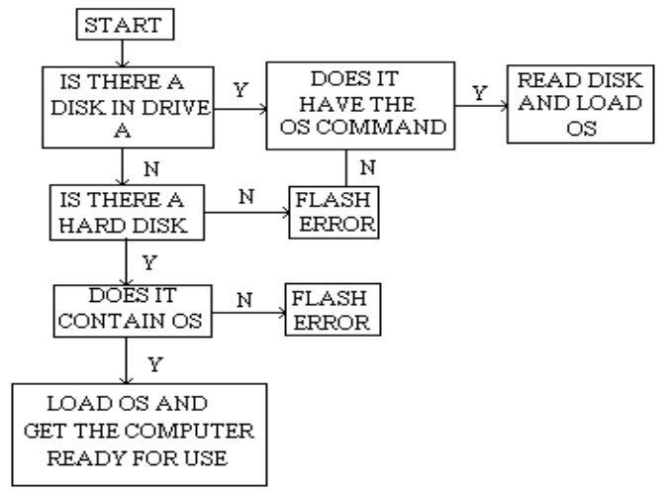

Figure 11

The figure above describes the way the operating system is ‘searched’ for and loaded in the RAM for the computer to be ready for use. After the POST, the ROM searches for the operating system. First it checks or a disk in the floppy disk drive. If a disk is found in drive A, ROM searches for the operating system files on it. If found, they are loaded in the RAM and the computer gets ready for use. If the operating system files are not found, the computer flashes an error message across the screen.

After this, the user has to replace the disk and press the ‘Return’ key. If the return key is pressed without replacing the disk, the operating system files are searched on the hard disk. If these files are not found even on the hard disk, the computer cannot get ready to accept commands from the user. If the files are found on the hard disk, they are copied to the RAM and the computer can be used.

Bootable Disk: It is very common and convenient to have the operating system files on the hard disk. However, sometimes due to some error the hard disk does not get read. This is why, a backup of the operating system files should always be maintained. A floppy containing the backup of the operating system files is called a ‘bootable’ disk. A bootable disk allows the computer’s operating system to get loaded. Atleast two bootable disks should be prepared and maintained.

1.13.2 Virus, Anti-virus, Vaccines

Computer virus has been in the news for a long time. The amount of damage they can cause is really tremendous. This virus has been the reason for most people to get curious about computers. In this session we will explain what virus, anti-virus and vaccine is?

Virus is nothing but a program written using one of the computer languages, to cause damage to the data, the information or the hardware of the computer. In other words it is a destructive software.

A virus can replicate itself very easily. This is because along with the instructions it has for destroying data, it also has instructions for copying itself onto the memory of the computer. It also has instructions to copy itself in any floppy disk that is inserted into the floppy disk drive. It can multiply itself or make several copies of itself.

A computer that has the virus is called an infected computer or a host. Unfortunately, like a man who has the common cold virus and looks ill, the computer does not look ill. There is no way of knowing that the computer’s hard disk and RAM has virus, because these program files do not show up. However, the computer starts mal-functioning.

If a computer has a virus in its memory, the virus can get attached to the floppy in the computer. If anyone uses this ‘infected’ floppy on another computer, then that computer will also get infected. This is how virus spreads.

The most common damage that is done by a virus is:
- erase data from the hard disk
- increase the file size of command files by several 1000 bytes
- affect the hardware components

The reason that the term ‘virus’ has been borrowed from biology is that the computer virus also shows many similarities with the biological virus. These similarities are given below:

Biological Virus | Computer Virus
- Attaches itself to the victim through another victim | - Attaches itself to the computer through another infected computer
- Can multiply on its own very rapidly | - Also multiplies on its own very rapidly
- Can be cured with a vaccine | - Can be removed with a vaccine
- Infection can be prevented via an inoculation | - Infection can be prevented using a anti-virus software

Table 3
Programs that are used for preventing virus are called anti-virus software and programs that are used for removing the virus are called vaccines.

Some Famous Viruses:
Some of the viruses that have been discovered and fought off are –
- Amoeba
- Datacrime
- Fu Manchu
- April 1st
- Saturday the 14th
- Friday the 13th
- Yankee Doodle
- ...
All these viruses attach themselves to files and increase their file size, thereby occupying more space on the hard disk. Some viruses, like Friday the 13th attack only on that date and destroy (i.e. delete) all the data from the hard disk.

Many people wonder why such destructive programs are written. Writing programs to add numbers or to find out percentages can be learnt quickly. Most people can quickly learn to write programs for commercial applications. However, writing programs that can attach themselves to the memory of the computer and programs that can replicate themselves, require a lot of knowledge of the hardware as well as the language. In another words, writing these types of programs is quite difficult. There are people who actually feel proud of being able to do this ‘difficult’ task. Most of them do not realise the enormity of the damage they cause. Those who do realise this just don’t care. They are too pre-occupied with their own sense of feeling good to worry about other computer users. This is why people write destructive programs.

1.13.3 Data Compression

Data compression is a technique that reduces the volume of the data when it has to be copied on to the secondary storage devices. Large files, which are around 2 or 3 MB in size (or even more than that) cannot be stored on a single floppy. Thus, they will require many floppies and handling so many floppies becomes quite difficult. The whole process also becomes expensive because more storage is required. Data compression utilities, pack data bits close to each other and reduce the size of a file by about 40 to 60 percent. Depending on which software is being used for doing this, a file of size 1 MB can be compressed to about 400 to 600 KB.

There are several utilities in Windows to compress files. The most popular utility, which is available on Windows, is called WINZIP. Here the files have to be ‘zipped’ first. This compresses them. But, when we need to use these files, they have to be ‘unzipped’ i.e. they have to return to their normal form so that they can be read.

1.13.4 File Creation

Most programs create a file, sometime or the other. The actual job of creating a file is left to the operating system. Take a look at the following table:
User enter data through the keyboard

All the data is ‘waiting’ in the RAM

After the user is sure about the data, he ‘saves’ the data

Saving causes the hard disk to be accessed

Figure 12
The operating system searches for some free space on the hard disk
Next, the data is copied from the RAM to the free space on the hard disk

The program asks the user for a name that will be given to the area where the data is stored on the hard disk. This area is called a file and the name given to this area is the file name.

When the user wants to access that data again, he will ask the program for that file by using the file name. Using that filename will cause the operating system to access only that area where the required data is present. This is how a file gets created on the computer and accessed for later use.

1.13.5 Software Manuals, Versions and Upgrades

Software is the result of many people putting their heads together to churn out a product that will cater to the needs of a wide range of users. Months are spent writing programs, testing them and correcting them. After all the programs have been written, tested and corrected, the software is said to be ready. This ready-made software is sold in the market to users who range from computer professionals, to other professionals who use the computer as a tool. All these users have to be taught how to use the software. No matter how user friendly the software is, there is always the need to refer to some book that will tell the user how to use the software.

When we buy a new appliance like a refrigerator, or a television, we too need some type of a documentation that will guide us on:

- how to set up the appliance
- how to maintain it
- how to use all the features available on it
- how to fix small problems that may arise while using it

This documentation is required, no matter how familiar we are with using televisions or refrigerators. This type of documentation is known as a user’s manual.

Ready-made software too comes with a user’s manual. All manuals however, speak only about the product. There is no information regarding the knowledge that may be a pre-requisite for using that software. This means that for a manual that shows a user how to use PowerPoint, the manual will assume that the user has complete knowledge of the Windows operating environment.

Next, all software keeps getting improvised by the people who develop it. This happens because it is only after extensive use by the users, do all the mistakes in the program become known. After the errors get noticed, they are rectified and a new version of the software gets released. For example when the GUI based operating environment was first released, it was just called Windows. Then there was Windows 3.1, Windows 3.11 and Windows 95/98/ME/2000/XP/2003. The latest is Windows Longhorn. Each release comes with more and more improvisations.

Some software companies offer a free upgrade of the software to the user who has purchased the earlier version. This happens when the difference between the versions is not too much. When there is a big difference in the two versions, the users of the old version are offered the new version at a discounted price. For example, when Windows 95 was developed and released in the market by Microsoft, all the users who had purchased Windows 3.11 were given a copy of Windows 95 at a discounted price.

1.13.6 Software Copyright

All of us at one time or another have heard of terms like ‘music piracy’ or ‘video piracy’. Whenever, a song or a movie is made, the maker of that song or movie has to ensure that each and every person who is watching the movie or listening to the song has purchased the legal copy. Some people buy one copy, make an inferior quality copy of it and then sell it in the market at a lower rate. This is unfair to the maker of the movie because he does not get paid for the product which is rightfully his. This is called piracy.

As mentioned earlier, people spend months, writing programs to create software. Software also gets copied illegally and is distributed in the market at rates, which are one tenth or less of the original price. This is called software piracy. Large companies like Microsoft have appointed agents all over the world to ensure that all the copies of there product being used are legal and not pirated.
The governments of these countries also ensure that piracy is an offense that is seriously punishable. All users of computers are urged not to use illegal copies of software. This is why there is a copyright on software also.

The Session in Brief
Computer Hardware

- The input/output work in a computer is controlled by controllers who work with the processor to make sure that there is no clash of data.

- The bus transports data between the processor and the other components. Some examples are the data bus and the control bus.

- Ports are access points for the entry or the exit of data. Serial ports allow only a single bit of data to pass through.

- Parallel ports allow the passage of more than one bit, i.e. 8 bits at a time.

- Memory is classified into primary memory and secondary memory.

- The primary memory mainly consist of the RAM and ROM.

- The hard disk drive is the work horse of the computer system and it is required for processing , reading and writing data.

- Computers are classified according to:
- Purpose : Analog, Digital, Hybrid
- Size and
Processing Power : Microcomputers, Minicomputers, Mainframes,
Supercomputers
- Components :Generations of computers

Computer Software

- Software can be defined as a set of instructions that are given to the computer to process data and give information. These sets of instructions are called ‘programs’.

- A related set of tasks is called an application. When many such programs are written for a related set of tasks or application, it is called an application software.

- There are three types of files, namely the data file, the program file and the text file.

- Computer languages have developed a great deal since they were first used. Their evolution spans about four stages, which are referred to as generations. They have been classified as first generation, second generations, third generation and fourth generation language.

- A wide range of software is now available to us where many of our day to day applications have been computerised. This software is easy to use and requires minimum learning. Some of the applications for which the computer is used are discussed below:

- Letter writing
- Publishing
- Keeping records
- Doing maths
- Painting and drawing
- Telecommunications
- Games

- Housekeeping in computers refers to maintaining of the computer hardware, the computer software and the data.

- Virus is nothing but a program written using one of the computer languages, to cause damage to the data, the information or the hardware of the computer. Programs that are used for preventing virus are called anti-virus software and programs that are used for removing the virus are called vaccines.

- Data compression is a technique that reduces the volume of the data when it has to be copied on to the secondary storage devices.

- Software piracy is when the software gets copied illegally and is distributed in the market at rates, which are one tenth of the original price.
Check Your Progress

Computer Hardware

- The data in the computer travels on paths called .

- The three types of buses found in the computer are , and .

- are access point for the entry and exit of data.

- A serial port is also called a port.

- The Centronics port is called a port.

- allow faster processing by using multiple processors and superior technology and are used for complex tasks which require a lot of computational power.

- computers process information using numbers which is essentially in a binary or a two state format.

- Memory is essentially divided into and memory.

- memory is volatile in nature.

- The features of and machines are combined to create a hybrid computing system.

Computer Software

- Program is .

- Software is .

- What is user-friendly software?

- What is an application?

- The three types of files are , and .

- , , and are examples of application software.

- What is housekeeping?

- Computer languages have to be translated to ..

- Microsoft is headed by .

- The computer understands only and .

- POST stands for .

- A destructive program is called a .

- What is data compression used for?

- What is the difference between a vaccine and an anti-virus?

- Software is illegal.

❖    

This page has been intentionally left blank

